Risk of having a stroke

Student's Name
Institutional Affiliation
Course Name
Instructors' Name
Date

Risk of having a stroke
Summary
The core purpose of this analysis is to assess the risk of having strokes. The three primary objectives of the study includes; the relationship between gender/age and the rate of cholesterol; whether high cholesterol increases the risk of heart attack and whether high cholesterol increases the risk of stroke The study then uses a dataset downloaded from https://www.kaggle.com/rashikrahmanpritom/heart-attack-analysis-prediction-dataset, containing different blood pressure levels taken from other people from both genders. Data visualization will be done to display the findings of each analysis.
Introduction
Several health conditions such as age, lifestyle, and family history can increase the risk for heart disease and heart attack (Atheroscler, 2021). While there are different risk factors for heart diseases, some of these are not preventable and include older age and a family history of the disease (Benjamin, 2019). However, most risk factors are modifiable, such as smoking, high blood pressure and cholesterol, diabetes, physical inactivity, being overweight, excessive alcohol consumption, and poor diet (mainly through its negative impact on weight, cholesterol, and blood pressure (Fry, 2019). The study shall use R Studio analysis software to visualize the differences before drawing up valid conclusions.
Data Analysis
Data was imported the data from excel to RStudio and then put in the form of a data frame. This was followed by a classification of the data resting electrocardiographic results where 0 represented yes, and 1 represented no. The summary was calculated separately and then plotted to scatter plot, a histogram, and a boxplot to see the different visualization for the three objectives and results. This was to see the visualization for all three hypotheses.
The following R codes were used to conduct the analysis.
Heart<-read.csv("C:/Users/LATITUDE 3440/Desktop/Excel Documents/Heart.csv")
Heart
attach(Heart)
summary(age,chol, data=Heart)
class(Heart)
str(Heart)
reg.lm1<- lm(chol~age, Heart)
plot(chol~age,main= "Scatter plot for Cholestrol and Age", data= Heart)
> abline(coef(reg.lm1))
reg.lm1
hist(Heart$restecg,freq=FALSE,main="Histogram",ylab="chol",col="red")
restecg1<-factor(restecg,levels=c(0,1),labels=c("Yes","No"))
wel<-table(Heart$chol,Heart$restecg)
chisq.test(wel,correct =FALSE)
ggplot(Heart,aes(x=restecg,y=trtbps),col="green")+geom_boxplot()
wel1<- table(Heart$trtbps,Heart$restecg)
chisq.test(wel1,correct = FALSE)
Results
After analyzing data of 96 men and 207 women, making a total of 303 to assess whether there exist a significant relationship between the gender/age and the rate of cholesterol, whether the high rate of cholesterol increase the risk of having a heart disease and stroke and whether a high resting blood pressure increase the risk of a patient to have a heart attack. The summary statistics output displayed by age and cholesterol below;
summary (age, data=Heart)
Min. 1st Qu. Median Mean 3rd Qu. Max.
29.00 47.50 55.00 54.37 61.00 77.00
summary(chol, data=Heart)
Min. 1st Qu. Median Mean 3rd Qu. Max.
126.0 211.0 240.0 246.3 274.5 564.0
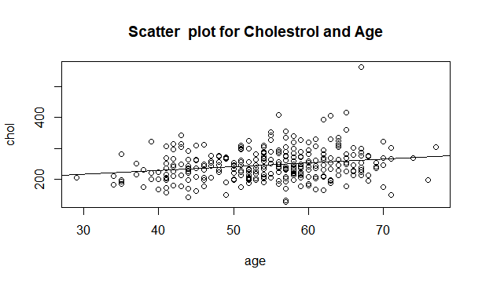
Regression analysis to establish the relationship,
> reg.lm1
Call:
lm(formula = chol ~ age, Heart)
Coefficients:
(Intercept) age
179.967 1.219
Hence formula is;
chol= 179.967 + 1.219age
This implies that cholesterol level is directly proportional to age.
ANOVA table
> ANOVA (reg.lm1)
Analysis of Variance Table
Response: chol
Df | Sum Sq | Mean Sq | F value | Pr(>F)
age 1 | 37043 | 37043 | 14.401 | 0.0001786 ***
Residuals 301 774258 |  | 2572
Signif. codes: 0 ‘***’ 0.001 ‘**’ 0.01 ‘*’ 0.05 ‘.’ 0.1 ‘ ’ 1

Comparing the p-value with a significance level of 0.05, and since the p-value is less than the significance value, we, therefore, rejects H0.
In conclusion, there is a significant relationship between gender/age and the rate of cholesterol positively.
HISTOGRAM
The second hypothesis stated;
H0: The high rate of cholesterol does not increase the risk of having heart disease and stroke
H1: The high rate of cholesterol increases the risk of having heart disease and stroke
Chol means cholesterol
Respect means resting electrocardiographic
0= "yes."
1= "No."
We, therefore, use chi Square to assess if the high rate of cholesterol increases the risk of having heart disease and stroke or not.
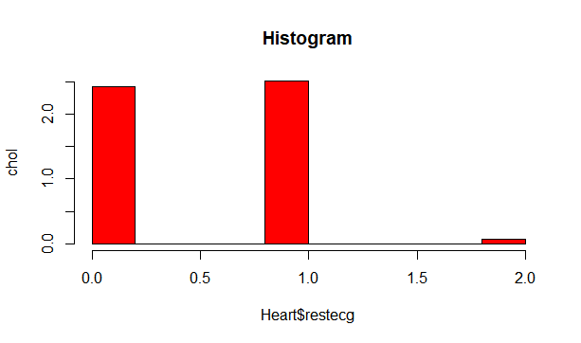
Chi square
Chi square results;
chisq.test(wel,correct =FALSE)

Pearson's Chi-squared test
data: wel
X-squared = 329.1, df = 302, p-value = 0.136
At 95% confidence, the p-value (0.136) is greater than the significance value; we, therefore, fail to reject our null hypothesis(H0).
In conclusion, the high rate of cholesterol does not increase the risk of having heart disease and stroke. The Chi-square test indicates insufficient evidence to conclude that the observed distribution is not the same as the expected distribution. We, therefore, can conclude that a relationship does not exist between the categorical variables.
Box plot
Third hypothesis;
H0: High resting blood pressure insignificantly increases the risk of a patient having a heart attack.
H1: High resting blood pressure significantly increases the risk of a patient having a heart attack.
In this case, we are using
#trtbpssort
resting blood pressure (in mm Hg)
and #restecgsort
resting electrocardiographic results
From the data.
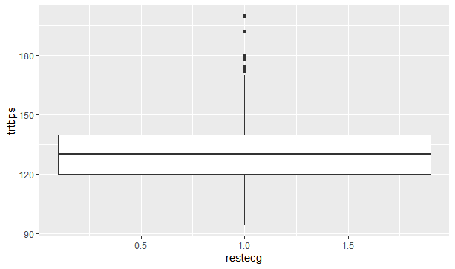
Using the measure of central tendency, median, to explain this, it clear from the box plot above that High resting blood pressure significantly increase the risk of a patient to have a heart attack.
chisq.test (wel1, correct = FALSE)
Pearson's Chi-squared test
data: wel1
X-squared = 150.02, df = 96, p-value = 0.0003529
From the Chi-square results above, the p-value is less than the significance level,0.05; hence we reject H0.

Conclusion
In conclusion, high resting blood pressure significantly increases the risk of a patient having a heart attack. From the analysis done above, we conclude that there exists a significant relationship between gender/age and the rate of cholesterol in a positive manner, the high rate of cholesterol does not increase the risk of having heart disease and stroke, and finally, high resting blood pressure significantly increase the risk of a patient to have a heart attack.

References
Benjamin EJ, Muntner P, Alonso A, Bittencourt MS, Callaway CW, Carson AP, et al. Heart disease and stroke statistics—2019 update: a report from the American Heart Association. Circulation. 2019;139(10):e56–528.
Fryar CD, Chen T-C, Li X. Prevalence of uncontrolled risk factors for cardiovascular disease: the United States, 1999–2010 pdf icon[PDF-494K]. NCHS data brief, no. 103. Hyattsville, MD: National Center for Health Statistics; 2012. Accessed May 9, 2019.
J Lipid Atheroscler. 2021 Jan;10(1):88-98. doi: 10.12997/jla.2021.10.1.88. Epub 2021 Jan 5.PMID: 3353725

